User stories:

https://premieragile.com/3cs-of-user-story/

1.User story is a simple and precise description of the project which helps to explain the ultimate objective about the project that is desired to be achieved, to the customers.

2.In the agile environment, when developers write the requirements, but the customers who are new will find difficulty in understanding the technical language. So this is solved through the user stories.

3.A project id split into several parts called epics and then further broke into smaller units,these units are called the user stories.

4.For writing the user stories we are using 3 C's of user stories:

* Cards
* Conversation
* Confirmation
* Cards- cards are where user stories are written. Before cards are written manually but nowadays it is digital ,the user stories will be written in the cards,that helps to know what the story is about based on the customer needs. It is used for planning also. It is the starting point of the user stories.
* Conversation- when a user story is written on the card and put in the board, it reflects the commitment of team, to discuss the user story. So the team holds a conversation on a user story, It is nothing but a exchange of ideas and viewpoints.
* Confirmation- It is the acceptance criteria that should be fulfilled and tested to ensure that user requirements has met and delivered correctly.

What are stories, epics, and initiatives?

* [**Stories**](https://www.atlassian.com/agile/project-management/user-stories), also called “user stories,” are short requirements or requests written from the perspective of an end user.
* [**Epics**](https://www.atlassian.com/agile/project-management/epics) are large bodies of work that can be broken down into a number of smaller tasks (called stories). (Multiple user stories are called as epic)
* **Initiatives** are collections of epics that drive toward a common goal.(multiple epics are called as Initiatives).

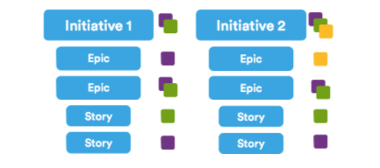

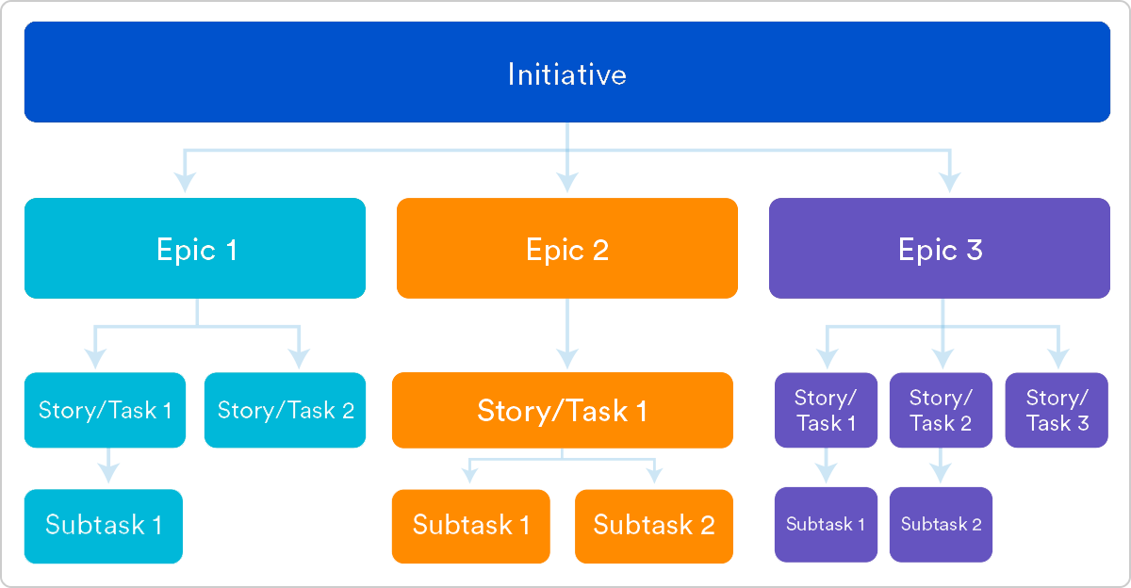

Template:

As a < type of user >, I want < some goal > so that < some reason >.

As a < type of user> ------> Who

I want < some goal > ------> What

so that < some reason > ------> Why

Example:

* As a trainer, I want my profile to list my upcoming classes and include a link to a detailed page about each so that prospective attendees can find my courses.

INVEST – it sets a quality to the user stories.

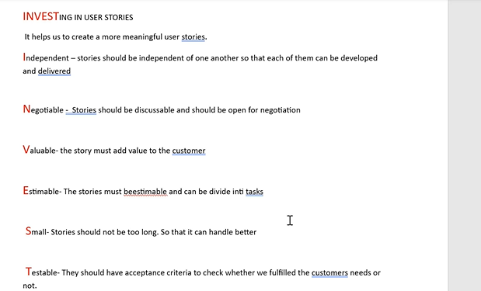

Acceptance criteria:

**Acceptance criteria (AC)** are the conditions a software product must meet to be accepted by a user, a customer, or other systems. They are unique for each user story and define the feature behavior from the end-user’s perspective.

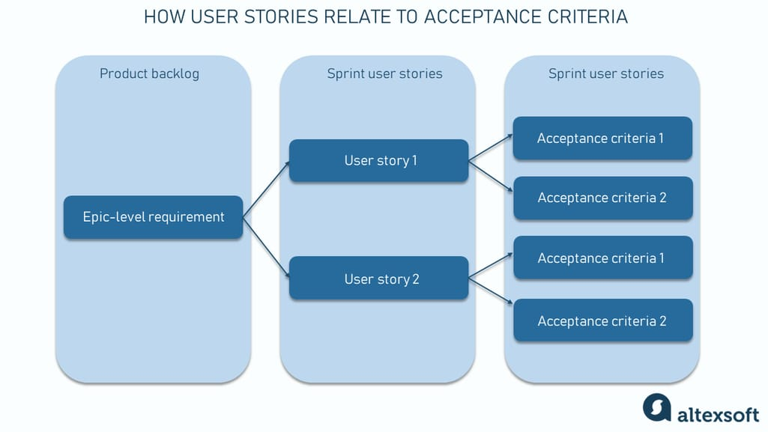

Based on the initial task and the complexity of requirements, you can choose between different acceptance criteria formats, namely:

* scenario-oriented (the Given/When/Then acceptance criteria template);
* rule-oriented (the checklist acceptance criteria template); and
* custom formats.





